Lab 4 Report
The purpose of this lab is to solidify you to the usage of some important lab equipments. This lab will allow you to learn about, multiple voltage source, voltage source and current source together, a breadboard, and a multimeter.

Component List
- 2 x 4.7kOhm Resistor
- 2 x 560Ohm Resistor
- 1 x 330Ohm Resistor
- 1 x 220Ohm Resistor

Useful Equations

Experiment 1
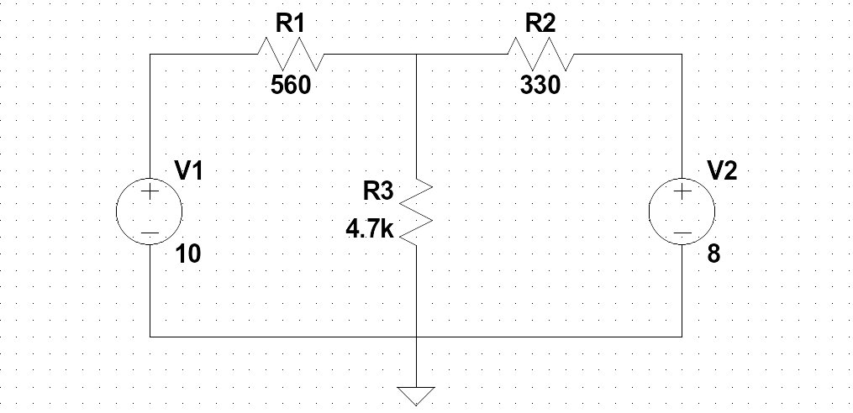Figure 1: Circuit diagram of Experiment 1.

Components and Instruments used:
- A computer: used in the pre-lab to get experiment details from the Moodle
- Resistor kit: contains the resistors to create circuits in the breadboard
- Tektronix PS280 power supply: voltage source
- Fluke multimeter: used to get measurements such as potential difference, current, etc.
- Breadboard: used to create circuits and connect wires to find values

Procedure:
- Create the circuit shown in Figure 1 on breadboard using the shown resistor values.
- Connect the power supply and set it to the 12V of DC voltage.
- Set the multimeter to voltage measurement mode and for each resistor, connect the multimeter as parallel to the resistors and measure the voltage drops.
- Set the multimeter to current measurement mode and for each resistor, connect the multimeter as series before or after to the resistor that you want to measure the current passing through.

Results
RESULTS WITHOUT UNITS WILL NOT BE GRADED!
Table 1: Voltage measurements.
VARIABLE | CALCULATED | MEASURED | ERROR%
V_{R1}
V_{R2}
V_{R3}

Table 2: Current measurements.
VARIABLE | CALCULATED | MEASURED | ERROR%
I_{R1}
I_{R2}
I_{R3}

Experiment 2
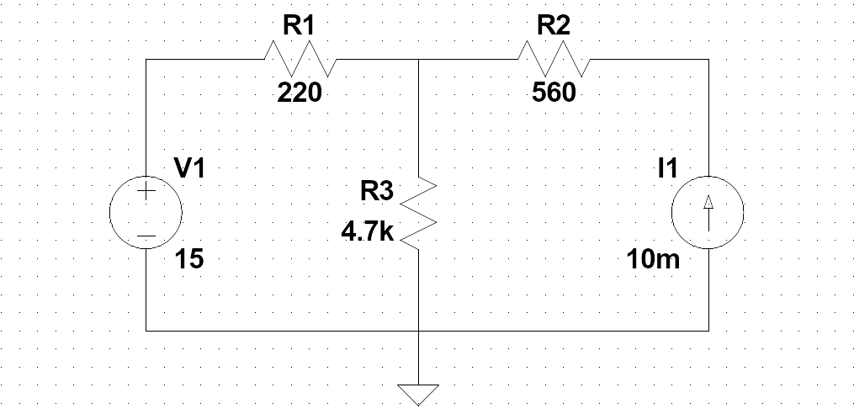Figure 2: Circuit diagram of Experiment 2.

Components and Instruments used:
- A computer: used in the pre-lab to get experiment details from the Moodle
- Resistor kit: contains the resistors to create circuits in the breadboard
- Tektronix PS280 power supply: current source
- Fluke multimeter: used to get measurements such as potential difference, current, etc.
- Breadboard: used to create circuits and connect wires to find values

Procedure:
- Create the circuit shown in Figure 2 on breadboard using the shown resistor values.
- Connect the power supply in constant voltage mode and set the voltage to 9V.
- Set the multimeter to voltage measurement mode and for each resistor, connect the multimeter as parallel to the resistors and measure the voltage drops.
- Set the multimeter to current measurement mode and for each resistor, connect the multimeter as series before or after to the resistor that you want to measure the current passing through.

Results
RESULTS WITHOUT UNITS WILL NOT BE GRADED!
Table 3: Voltage measurements.
VARIABLE | CALCULATED | MEASURED | ERROR%
V_{R1}
V_{R2}
V_{R3}
Table 4: Current measurements.
VARIABLE | CALCULATED | MEASURED | ERROR%
I_{R1}
I_{R2}
I_{R3}

